PRACTICAL 1

- Given an array of non-negative integers, design a linear algorithm and implement it using a program to find whether given key element is present in the array or not. Also, find total number of comparisons for each input case. (Time Complexity = O(n), where n is the size of input)

Source Code:

#include <bits/stdc++.h>
using namespace std;

void solve()
{
int n;
cin >> n;
vector<int> v(n);
for (int &it : v)
cin >> it;
int target;
cin >> target;
int comparison = 0;
bool ok = 0;
for (int it : v)
{
comparison++;
if (it == target)
{
ok = 1;
break;
}
}
if (ok)
{
cout << "Present " << comparison << endl;
}
else
{
cout << "Not Present " << comparison << endl;
}
}

int main()
{
int t;
cin >> t;
while (t--)
{
solve();
}
return 0;
}

OUTPUT:

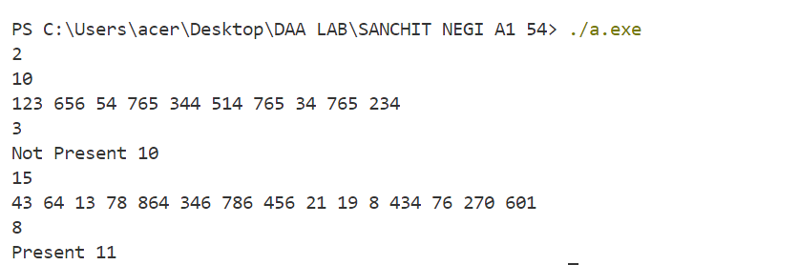

PRACTICAL 2

- Given an already sorted array of positive integers, design an algorithm and implement it using a program to find whether given key element is present in the array or not. Also, find total number of comparisons for each input case. (Time Complexity = O(logn), where n is the size of input).

Source Code:

#include <bits/stdc++.h>
using namespace std;

void solve()
{
int n;
cin >> n;
vector<int> v(n);
for (int &it : v)
cin >> it;
int target;
cin >> target;
int low = 0, high = n - 1, comparison = 0;
bool ok = 0;
while (low <= high)
{
int mid = low + (high - low) / 2;
comparison++;
if (v[mid] == target)
{
ok = 1;
break;
}
else if (v[mid] < target)
{
low = mid + 1;
}
else
{
high = mid - 1;
}
}
if (ok)
{
cout << "Present " << comparison << endl;
}
else
{
cout << "Not Present " << comparison << endl;
}
}

int main()
{
int t;
cin >> t;
while (t--)
{
solve();
}
return 0;
}

OUTPUT:

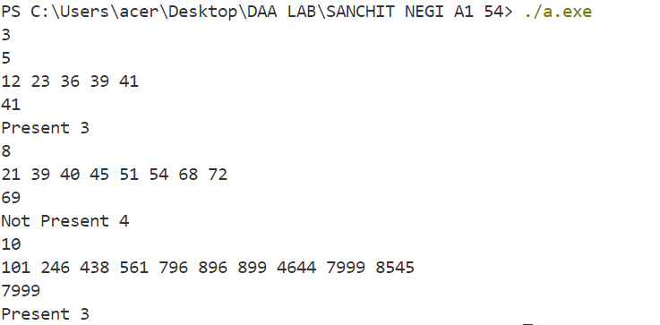

PRACTICAL 3

- Given an already sorted array of positive integers, design an algorithm and implement it using a program to find whether a given key element is present in the sorted array or not. For an array arr[n], search at the indexes arr[0], arr[2], arr[4],.....,arr[2^{k}] and so on. Once the interval (arr[2^{k}] < key < arr[ 2^{k+1}] ) is found, perform a linear search operation from the index 2^{k} to find the element key. (Complexity < O(n), where n is the number of elements need to be scanned for searching): Jump Search

Source Code:

#include <bits/stdc++.h>
using namespace std;

void solve()
{
int n; cin >> n;
vector<int> v(n);
for (int &it : v)
cin >> it;
int target; cin >> target;
int low = 0, high = n - 1, comparison = 0;
bool ok = 0;
while (low <= high) // searching at index 0,2,4,8,16,32,...........->1
{
comparison++;
if (v[low] == target)
{
ok = 1;
break;
}
else if (v[low] > target) // Maybe target is present in between low and high.......->2
{
high = low;
low = 1 << (comparison - 2);
break;
}
else // increment low when target is greater ............->3
{
low = 1 << comparison;
}
}

if (!ok)
{
for (int i = low + 1; i <= high; i++) // linear search when target maybe present from 2
{
comparison++;
if (v[i] == target)
{
ok = 1;
break;
}
}
}

if (ok)
{
cout << "Present " << comparison << endl;
}
else
{
cout << "Not Present " << comparison << endl;
}
}

int main()
{
int t;
cin >> t;
while (t--)
solve();

return 0;
}

OUTPUT:
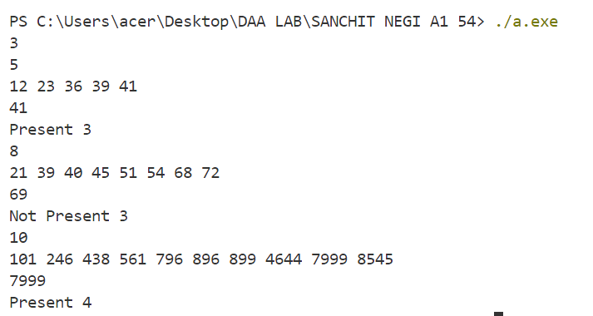

PRACTICAL 4

- Given a sorted array of positive integers containing few duplicate elements, design an algorithm and implement it using a program to find whether the given key element is present in the array or not. If present, then also find the number of copies of given key. (Time Complexity = O(log n))

Source Code:

#include <bits/stdc++.h>
using namespace std;

int findOccurance(const vector<int> nums, int target, string s)
{
int n = nums.size();
int left = 0, right = n - 1;
int position = -1;

while (left <= right)
{
int mid = left + (right - left) / 2;
if (nums[mid] == target)
{
position = mid;
if (s == "first")
right = mid - 1;
else if (s == "last")
left = mid + 1;
}
else if (nums[mid] < target)
{
left = mid + 1;
}
else
{
right = mid - 1;
}
if (right >= n || left < 0)
{
break;
}
}

return position;
}

void solve()
{
int n;
cin >> n;
vector<int> nums(n);
for (int i = 0; i < n; i++)
cin >> nums[i];

int target;
cin >> target;

int first = findOccurance(nums, target, "first");
int last = findOccurance(nums, target, "last");
if (first == -1)
{
cout << "Key not present\n";
}
else
{
cout << nums[first] << " - " << last - first + 1 << endl;
}
}

int main()
{
int t;
cin >> t;
while (t--)
{
solve();
}
return 0;
}

OUTPUT:

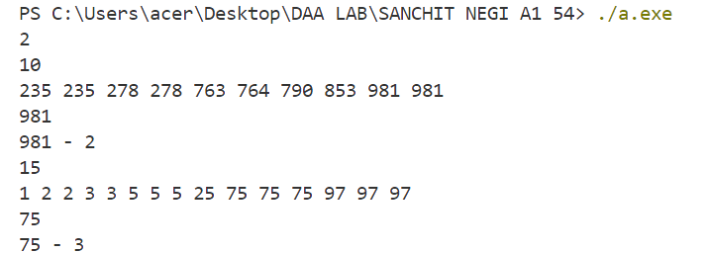

PRACTICAL 5

- Given a sorted array of positive integers, design an algorithm and implement it using a program to find three indices i, j, k such that arr[i] + arr[j] = arr[k].

Source Code:

#include <bits/stdc++.h>
using namespace std;

void solve()
{
int n;
cin >> n;
vector<int> nums(n);
for (int i = 0; i < n; i++)
cin >> nums[i];

for (int i = 0; i < n; i++)
{
for (int j = i + 1; j < n; j++)
{
for (int k = j + 1; k < n; k++)
{
if (nums[i] + nums[j] == nums[k])
{
cout << i + 1 << "," << j + 1 << "," << k + 1 << endl;
return;
}
}
}
}
cout << "No sequence found.\n";
}

int main()
{
int t;
cin >> t;
while (t--)
{
solve();
}
return 0;
}

OUTPUT:

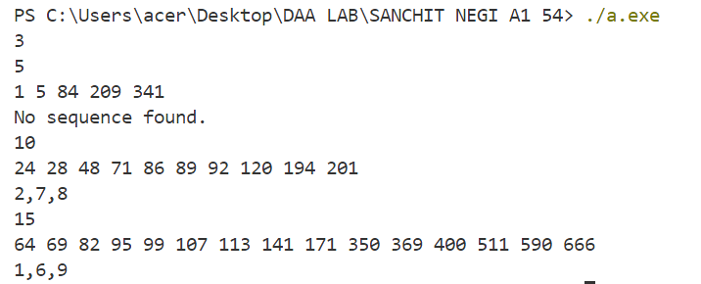

PRACTICAL 6

- Given an array of nonnegative integers, design an algorithm and a program to count the number of pairs of integers such that their difference is equal to a given key, K.

Source Code:

#include <bits/stdc++.h>
using namespace std;

void solve()
{
int n;
cin >> n;
vector<int> nums(n);
for (int i = 0; i < n; i++)
cin >> nums[i];
int target, cnt = 0;
cin >> target;

for (int i = 0; i < n; i++)
{
for (int j = i + 1; j < n; j++)
{
if (abs(nums[i] - nums[j]) == target)
{
cnt++;
}
}
}
cout << cnt << endl;
}

int main()
{
int t;
cin >> t;
while (t--)
{
solve();
}
return 0;
}

OUTPUT:

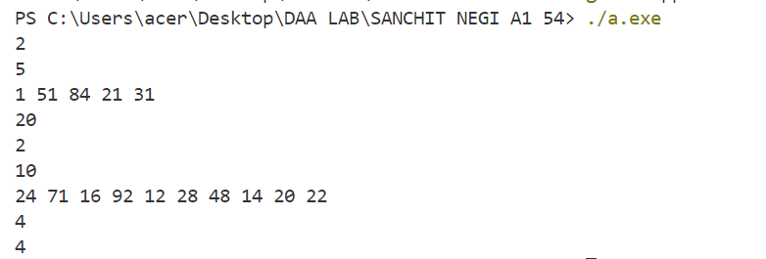

PRACTICAL 7

- Given an unsorted array of integers, design an algorithm and a program to sort the array using insertion sort. Your program should be able to find number of comparisons and shifts ( shifts - total number of times the array elements are shifted from their place) required for sorting the array.

Source Code:

#include <bits/stdc++.h>
using namespace std;

void solve()
{
int n;
cin >> n;
vector<int> nums(n);
for (int i = 0; i < n; i++)
cin >> nums[i];

int comparisons = 0, shifts = 0;
for (int i = 1; i < n; i++) // Insertion Sort
{
int j = i;
int curr = nums[j];
while (j - 1 >= 0 && nums[j - 1] > curr)
{
nums[j] = nums[j - 1];
shifts++;
comparisons++;
j--;
}
nums[j] = curr;
shifts++;
}

for (int it : nums)
cout << it << " ";
cout << endl;
cout << "Comparisons: " << comparisons << endl;
cout << "Shifts: " << shifts << endl;
}

int main()
{
int t;
cin >> t;
while (t--)
{
solve();
}
return 0;
}

OUTPUT:

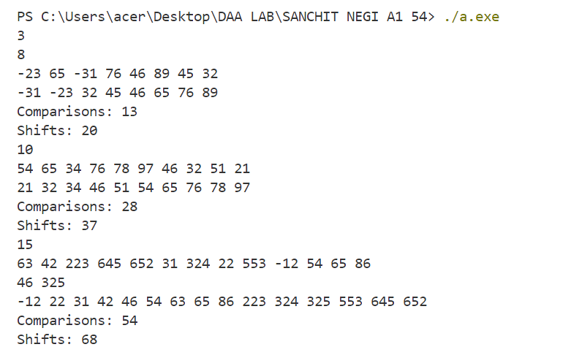

PRACTICAL 8

- Given an unsorted array of integers, design an algorithm and implement a program to sort this array using selection sort. Your program should also find number of comparisons and number of swaps required.

Source Code:

#include <bits/stdc++.h>
using namespace std;

void solve()
{
int n;
cin >> n;
vector<int> nums(n);
for (int i = 0; i < n; i++)
cin >> nums[i];

int comparisons=0,swaps=0;
for(int i=0;i<n-1;i++) // Selection sort
{
int minIndex=i;
for(int j=i+1;j<n;j++)
{
comparisons++;
if(nums[minIndex]>nums[j])
minIndex=j;
}
swap(nums[minIndex],nums[i]);
swaps++;
}

for(int it:nums)
cout<<it<<" ";
cout<<endl;
cout<<"Comparisons: "<<comparisons<<endl;
cout<<"Swaps: "<<swaps<<endl;
}

int main()
{
int t;
cin >> t;
while (t--)
{
solve();
}
return 0;
}

OUTPUT:

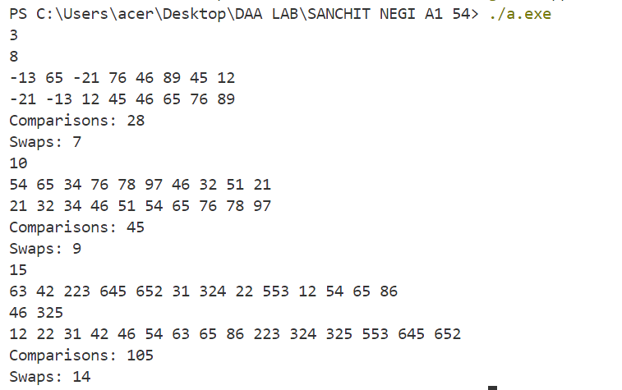

PRACTICAL 9

- Given an unsorted array of positive integers, design an algorithm and implement it using a program to find whether there are any duplicate elements in the array or not. (use sorting) (Time Complexity = O(n log n))

Source Code:

#include <bits/stdc++.h>
using namespace std;

void merge(vector<int> &nums, int l, int m, int r)
{
int i, j, k;
int n1 = m - l + 1;
int n2 = r - m;

int L[n1], R[n2];

for (i = 0; i < n1; i++)
L[i] = nums[l + i];
for (j = 0; j < n2; j++)
R[j] = nums[m + 1 + j];

i = 0,j=0,k=l;

while (i < n1 && j < n2)
{
if (L[i] <= R[j])
nums[k++] = L[i++];
else
nums[k++] = R[j++];
}

while (i < n1)
nums[k++] = L[i++];

while (j < n2)
nums[k++] = R[j++];
}

void mergeSort(vector<int> &nums, int l, int r)
{
if (l < r)
{
int m = l + (r - l) / 2;
mergeSort(nums, l, m);
mergeSort(nums, m + 1, r);
merge(nums, l, m, r);
}
}

void solve()
{
int n; cin >> n;
vector<int> nums(n);
for (int i = 0; i < n; i++)
cin >> nums[i];

mergeSort(nums, 0, n - 1);

bool ok = 0;
for (int i = 0; i < n - 1; i++)
if (nums[i] == nums[i + 1])
ok = 1;

cout << ((ok) ? "YES\n" : "NO\n");
}

int main()
{
int t; cin >> t;
while (t--)
solve();

return 0;
}

OUTPUT:

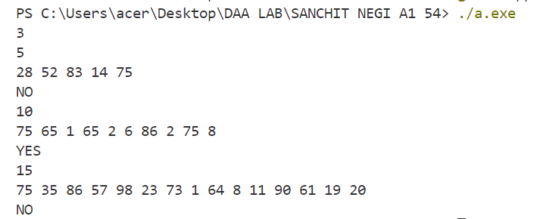

PRACTICAL 10

- Given an unsorted array of integers, design an algorithm and implement it using a program to sort an array of elements by dividing the array into two subarrays and combining these subarrays after sorting each one of them. Your program should also find number of comparisons and inversions during sorting the array.

Source Code:
#include <bits/stdc++.h>
using namespace std;
vector<int> merge(vector<int> &nums, int l, int m, int r)
{
int i, j, k;
int n1 = m - l + 1;
int n2 = r - m;

int L[n1], R[n2];

for (i = 0; i < n1; i++)
L[i] = nums[l + i];
for (j = 0; j < n2; j++)
R[j] = nums[m + 1 + j];

i = 0;
j = 0;
k = l;
int invCount = 0;
int comparisons = 0;

while (i < n1 && j < n2)
{
comparisons++;
if (L[i] <= R[j])
nums[k++] = L[i++];
else
{
nums[k++] = R[j++];
invCount += m - i;
}
}
while (i < n1)
nums[k++] = L[i++];

while (j < n2)
nums[k++] = R[j++];

return {comparisons, invCount};
}

vector<int> mergeSort(vector<int> &nums, int l, int r)
{
int invCount = 0;
int comparisons = 0;
vector<int> v(2);
if (l < r)
{
int m = l + (r - l) / 2;
v = mergeSort(nums, l, m);
comparisons += v[0], invCount += v[1];
v = mergeSort(nums, m + 1, r);
comparisons += v[0], invCount += v[1];
v = merge(nums, l, m, r);
comparisons += v[0], invCount += v[1];
}
return {comparisons, invCount};
}

void solve()
{
int n;
cin >> n;
vector<int> nums(n), v(2);
for (int i = 0; i < n; i++)
cin >> nums[i];

v = mergeSort(nums, 0, n - 1);

for (int it : nums)
cout << it << " ";
cout << endl;
cout << "Comparison: " << v[0] << endl;
cout << "Inversion: " << v[1] << endl;
}

int main()
{
int t;
cin >> t;
while (t--)
{
solve();
}
return 0;
}

OUTPUT:

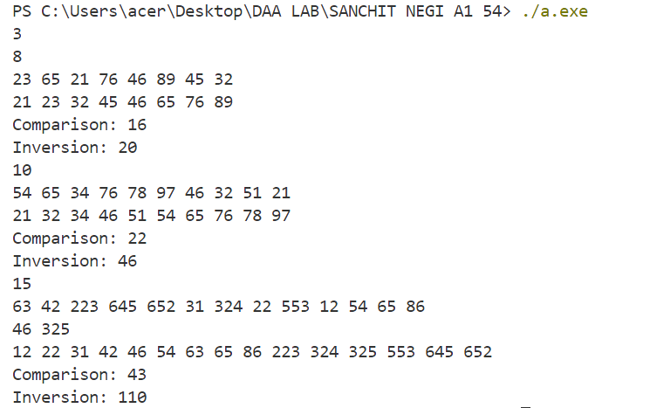

PRACTICAL 11

- Given an unsorted array of integers, design an algorithm and implement it using a program to sort an array of elements by partitioning the array into two subarrays based on a pivot element such that one of the sub array holds values smaller than the pivot element while another sub array holds values greater than the pivot element. Pivot element should be selected randomly from the array. Your program should also find number of comparisons and swaps required for sorting the array.

Source Code:

#include <bits/stdc++.h>
using namespace std;

int partition(vector<int> &nums, int low, int high, int &comparisons, int &swaps)
{
srand(time(0));
int random_index = low + rand() % (high - low + 1);
swap(nums[random_index], nums[high]);
swaps++;
int pivot = nums[high], i = (low - 1);

for (int j = low; j < high; j++)
{
if (nums[j] <= pivot)
{
i++,swaps++;
swap(nums[i], nums[j]);
}
comparisons++;
}
swap(nums[i + 1], nums[high]);
swaps++;
return (i + 1);
}

void quickSort(vector<int> &nums, int low, int high, int &comparisons, int &swaps)
{
if (low < high)
{
int pi = partition(nums, low, high, comparisons, swaps);
quickSort(nums, low, pi - 1, comparisons, swaps);
quickSort(nums, pi + 1, high, comparisons, swaps);
}
}

void solve()
{
int n; cin >> n;
vector<int> nums(n);
for (int i = 0; i < n; i++)
cin >> nums[i];

int comparisons = 0, swaps = 0;
quickSort(nums, 0, n - 1, comparisons, swaps);

for (int it : nums)
cout << it << " ";
cout << "\nComparison: " << comparisons << endl;
cout << "Swaps: " << swaps << endl;
}

int main()
{
int t; cin >> t;
while (t--)
solve();

return 0;
}

OUTPUT: 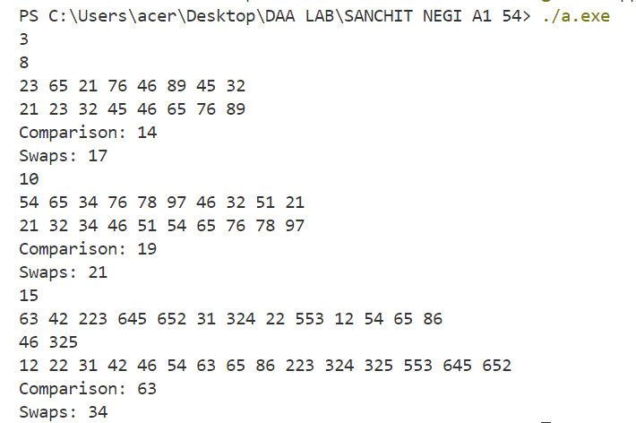

PRACTICAL 12

- Given an unsorted array of integers, design an algorithm and implement it using a program to find Kth smallest or largest element in the array. (Worst case Time Complexity = O(n))

Source Code:

#include <bits/stdc++.h>
using namespace std;

int partition(vector<int> &nums, int low, int high)
{
srand(time(0));
int random_index = low + rand() % (high - low + 1);
swap(nums[random_index], nums[high]);
int pivot = nums[high];
int i = (low - 1);

for (int j = low; j < high; j++)
{
if (nums[j] <= pivot)
{
i++;
swap(nums[i], nums[j]);
}
}
swap(nums[i + 1], nums[high]);
return (i + 1);
}

int kth_smallest(vector<int> &nums, int low, int high, int k)
{
if (k > 0 && k <= high - low + 1)
{
int pivot = partition(nums, low, high);

if (pivot - low == k - 1)
return nums[pivot];
if (pivot - low > k - 1)
return kth_smallest(nums, low, pivot - 1, k);
return kth_smallest(nums, pivot + 1, high, k - pivot + low - 1);
}
return -1;
}

void solve()
{
int n, k;
cin >> n;
vector<int> nums(n);
for (int i = 0; i < n; i++)
cin >> nums[i];
cin >> k;

int kth_smallest_element = kth_smallest(nums, 0, n - 1, k);
if (kth_smallest_element == -1)
{
cout << "Not Present" << endl;
}
else
{
cout << "Kth smallest element: " << kth_smallest_element << endl;
}
}

int main()
{
int t;
cin >> t;
while (t--)
{
solve();
}
return 0;
}

OUTPUT:

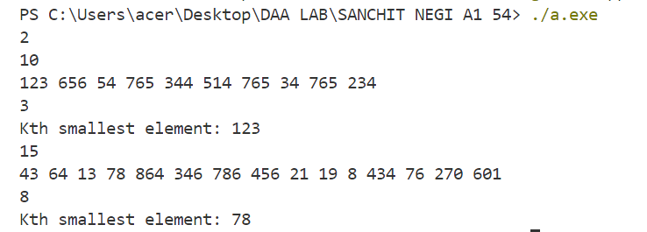

PRACTICAL 13

- Given an unsorted array of alphabets containing duplicate elements. Design an algorithm and implement it using a program to find which alphabet has a maximum number of occurrences and print it. (Time Complexity = O(n))

Source Code:

#include <bits/stdc++.h>
using namespace std;

int main()
{
int n;
cin >> n;
vector<char> v(n);
for (int i = 0; i < n; i++)
cin >> v[i];

int freq[26] = {0};
int maxi = 0;
for (char c : v)
{
freq[c - 'a']++;
maxi = max(maxi, freq[c - 'a']);
}

if (maxi == 1)
{
cout << "No Duplicate Present\n";
}
else
{
cout << "Maximum occurance\n";
for (int i = 0; i < 26; i++)
if (freq[i] == maxi)
cout << char(i + 'a') << endl;
}
return 0;
}

OUTPUT:
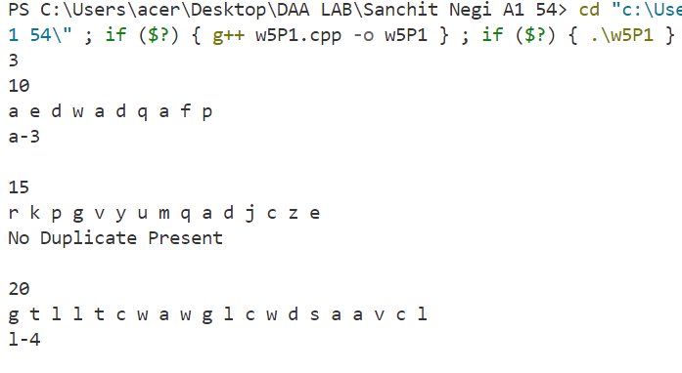

PRACTICAL 14

- Given an unsorted array of integers, design an algorithm and implement it using a program to find whether two elements exist such that their sum is equal to the given key element. (Time Complexity = O(n log n))

Source Code:

#include <bits/stdc++.h>
using namespace std;

void solve()
{
int n;
cin >> n;
vector<int> v(n);
for (int i = 0; i < n; i++)
cin >> v[i];
int target;
cin >> target;

map<int, int> mp;

vector<pair<int, int>> ans;
for (int i = 0; i < n; i++)
{
if (mp[target - v[i]])
{
ans.push_back({v[i], target - v[i]});
}

mp[v[i]]++;
}

if (ans.size() == 0)
{
cout << "No valid pair found\n";
}
else
{
cout << "Valid pair are:\n";
for (auto it : ans)
cout << it.first << " " << it.second << endl;
}
}

int main()
{
int t;
cin >> t;
while (t--)
{
solve();
cout << endl;
}
return 0;
}

OUTPUT:
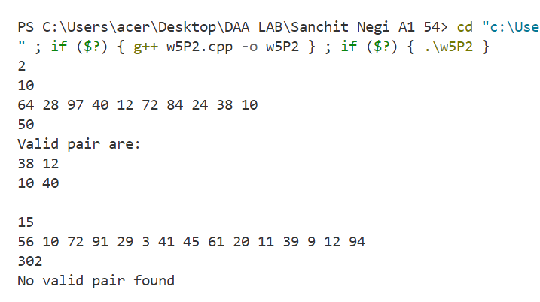

PRACTICAL 15

- You have been given two sorted integer arrays of size m and n. Design an algorithm and implement it using a program to find list of elements which are common to both. (Time Complexity = O(m+n))

Source Code:

#include <bits/stdc++.h>
using namespace std;

int main()
{
int n, m;
cin >> n;
vector<int> a(n);
vector<int> b(m);
for (int i = 0; i < n; i++)
cin >> a[i];
cin >> m;
for (int i = 0; i < m; i++)
cin >> b[i];

vector<int> ans;
int i = 0, j = 0;
while (i < n && j < m)
{
if (a[i] == b[j])
{
ans.push_back(a[i]);
i++, j++;
}
else if (a[i] < b[j])
{
i++;
}
else
{
j++;
}
}

if (ans.size() == 0)
{
cout << "No common element found\n";
}
else
{
cout << "Common elements are:\n";
for (auto it : ans)
cout << it << endl;
}
}

OUTPUT:

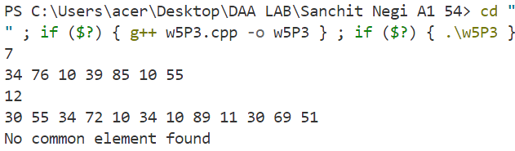

PRACTICAL 16

- Given a (directed/undirected) graph, design an algorithm and implement it using a program to find if a path exists between two given vertices or not. (Hint: use DFS)

Source Code:

#include<bits/stdc++.h>
using namespace std;

bool dfs(int src,int des,vector<vector<int>>adj,vector<bool>&visited)
{
if(src==des)
return true;

visited[src]=true;
for(int i=0;i<adj[src].size();i++)
{
if(adj[src][i]==1 && !visited[i])
if(dfs(i,des,adj,visited))
return true;
}
return false;
}

int main()
{
int n;cin>>n;
vector<vector<int>>adj(n,vector<int>(n));

for(int i=0;i<n;i++)
for(int j=0;j<n;j++)
cin>>adj[i][j];

int src,des;
cin>>src>>des;
vector<bool>visited(n,false);

if(dfs(src-1,des-1,adj,visited))
{
cout<<"Path Exists\n";
}
else
{
cout<<"Path Does not Exists\n";
}

return 0;
}

OUTPUT:

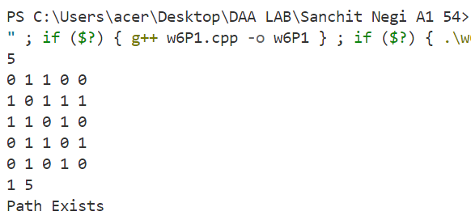

PRACTICAL 17

- Given a graph, design an algorithm and implement it using a program to find if a graph is bipartite or not. (Hint: use BFS)

Source Code:

#include <bits/stdc++.h>
using namespace std;

bool bfs(int src, vector<vector<int>> adj, vector<int> &visited)
{
queue<int> q;
q.push(0);
visited[0] = 1;
int color = 0;

while (!q.empty())
{
int node = q.front();
q.pop();

if (adj[node][node] == 1) // self loop
return false;

for (int i = 0; i < adj[node].size(); i++)
{
if (visited[i] == color)
return false;
else if (visited[i] == -1 && adj[node][i])
{
visited[i] = color;
}
}
color ^= 1;
}
return true;
}

int main()
{
int n;
cin >> n;
vector<vector<int>> adj(n, vector<int>(n));

for (int i = 0; i < n; i++)
for (int j = 0; j < n; j++)
cin >> adj[i][j];

vector<int> visited(n, -1);

if (bfs(0, adj, visited))
{
cout << "Graph is bipartite\n";
}
else
{
cout << "Graph is not bipartite\n";
}

return 0;
}

OUTPUT:

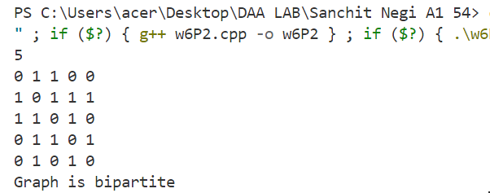

PRACTICAL 18

- Given a directed graph, design an algorithm and implement it using a program to find whether cycle exists in the graph or not

Source Code:

#include <bits/stdc++.h>
using namespace std;
// for directed graph(using bfs)
bool iscycle(unordered_map<int, vector<int>> &adj, int u, vector<bool> visited,vector<bool> &inRecursion)
{
visited[u] = true;
inRecursion[u] = true;
for (int &vec : adj[u])
{
// if not visited then we check for cycle in dfs
if (visited[vec] == false && iscycle(adj, vec, visited, inRecursion))
return true;
else if (inRecursion[vec] == true)
return true;
}
inRecursion[u] = false; // revert
return false;
}
int main()
{
int n;
cin >> n;
unordered_map<int, vector<int>> adj;
vector<bool> visited(n + 1, false);
vector<bool> inRecursion(n + 1, false);
for (int i = 1; i <= n; i++)
{
for (int j = 1; j <= n; j++)
{
int x;
cin >> x;
if (x == 1)
{
adj[i].push_back(j);
}
}
}
int flag = 0;
for (int i = 1; i <= n; i++)
{
if (!visited[i] && iscycle(adj, i, visited, inRecursion))
{
flag = 1;
cout << "CYCLE IS PRESENT" << endl;
return 0;
}
}
if (flag == 0)
{
cout << "CYCLE IS NOT PRESENT" << endl;
}
return 0;
}

OUTPUT:

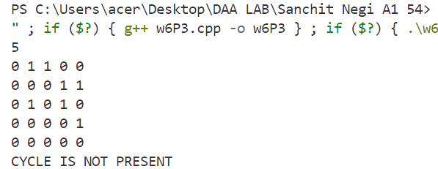

PRACTICAL 19

- After end term examination, Akshay wants to party with his friends. All his friends are living as paying guest and it has been decided to first gather at Akshay’s house and then move towards party location. The problem is that no one knows the exact address of his house in the city. Akshay as a computer science wizard knows how to apply his theory subjects in his real life and came up with an amazing idea to help his friends. He draws a graph by looking in to location of his house and his friends’ location (as a node in the graph) on a map. He wishes to find out shortest distance and path covering that distance from each of his friend’s location to his house and then whatsapp them this path so that they can reach his house in minimum time. Akshay has developed the program that implements Dijkstra’s algorithm but not sure about correctness of results. Can you also implement the same algorithm and verify the correctness of Akshay’s results? (Hint: Print shortest path and distance from friends’ location to Akshay’s house)

Source Code:

#include <bits/stdc++.h>
using namespace std;

// Dijkstra's algorithm
vector<int> dijkstra(int n, unordered_map<int, vector<pair<int, int>>> &adj, vector<int> &parent, int src)
{
vector<int> distances(n, INT_MAX);
distances[src] = 0;

priority_queue<pair<int, int>, vector<pair<int, int>>, greater<pair<int, int>>> pq;
pq.push({0, src});

// Dijkstra's algorithm
while (!pq.empty())
{
int u = pq.top().second;
int dist_u = pq.top().first;
pq.pop();

// Iterate through all adjacent nodes of u
for (auto &edge : adj[u])
{
int v = edge.first;
int weight = edge.second;

// Relaxation step: Update distance to v if shorter path through u is found
if (distances[u] + weight < distances[v])
{
distances[v] = distances[u] + weight;
parent[v] = u;
pq.push({distances[v], v}); // Push updated distance to v into the priority queue
}
}
}

return distances;
}

void display(vector<int> parent, int i)
{
if (parent[i] == -1)
{
cout << i + 1 << " ";
return;
}
display(parent, parent[i]);
cout << i + 1 << " ";
}

int main()
{
int n;
cin >> n;

vector<vector<int>> graph(n, vector<int>(n));
for (int i = 0; i < n; i++)
for (int j = 0; j < n; j++)
cin >> graph[i][j];

// Assuming input is adjacency list with weights (distances)
unordered_map<int, vector<pair<int, int>>> adj;
for (int i = 0; i < n; i++)
for (int j = 0; j < n; j++)
if (graph[i][j] != 0)
adj[i].push_back({j, graph[i][j]});

int akshayHouse;cin>>akshayHouse;
--akshayHouse ;

vector<int> parent(n, -1);
vector<int> distances = dijkstra(n, adj, parent, akshayHouse);

for (int i = 0; i < n; i++)
{
display(parent, i);
cout << " : " << distances[i] << endl;
}

return 0;
}

OUTPUT:

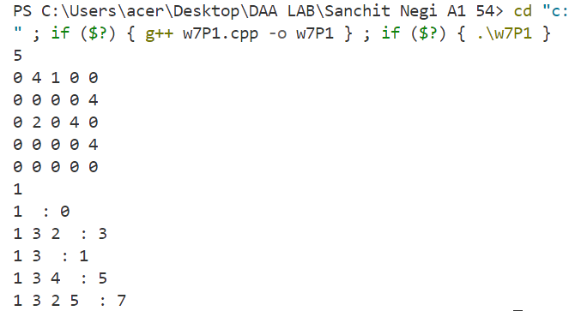

PRACTICAL 20

- Design an algorithm and implement it using a program to solve previous question's problem using Bellman- Ford's shortest path algorithm.

Source Code:

#include <bits/stdc++.h>
using namespace std;

// Bellman-Ford algorithm
vector<int> bellmanFord(int n, unordered_map<int, vector<pair<int, int>>> &adj, vector<int> &parent, int src)
{
vector<int> distances(n, INT_MAX);
distances[src] = 0;

// Relax all edges n-1 times
for (int i = 0; i < n - 1; ++i)
{
for (int u = 0; u < n; ++u)
{

for (auto &edge : adj[u])
{
int v = edge.first;
int weight = edge.second;
if (distances[u] != INT_MAX && distances[u] + weight < distances[v])
{
distances[v] = distances[u] + weight;
parent[v] = u;
}
}
}
}

// Check for negative-weight cycles
for (int u = 0; u < n; ++u)
{
for (auto &edge : adj[u])
{
int v = edge.first;
int weight = edge.second;
if (distances[u] != INT_MAX && distances[u] + weight < distances[v])
{
cout << "Graph contains negative weight cycle" << endl;
return {};
}
}
}

return distances;
}

void display(vector<int> parent, int i)
{
if (parent[i] == -1)
{
cout << i + 1 << " ";
return;
}
display(parent, parent[i]);
cout << i + 1 << " ";
}

int main()
{
int n;
cin >> n;

vector<vector<int>> graph(n, vector<int>(n));
for (int i = 0; i < n; i++)
for (int j = 0; j < n; j++)
cin >> graph[i][j];

// Assuming input is adjacency list with weights (distances)
unordered_map<int, vector<pair<int, int>>> adj;
for (int i = 0; i < n; i++)
for (int j = 0; j < n; j++)
if (graph[i][j] != 0)
adj[i].push_back({j, graph[i][j]});

vector<int> parent(n, -1);
int akshayHouse;
cin >> akshayHouse;
--akshayHouse;
// Run Bellman-Ford algorithm from Akshay's house
vector<int> distances = bellmanFord(n, adj, parent, akshayHouse);

// Print shortest distances from Akshay's house to all locations
for (int i = 0; i < n; i++)
{
display(parent, i);
cout << " : " << distances[i] << endl;
}

return 0;
}

OUTPUT:

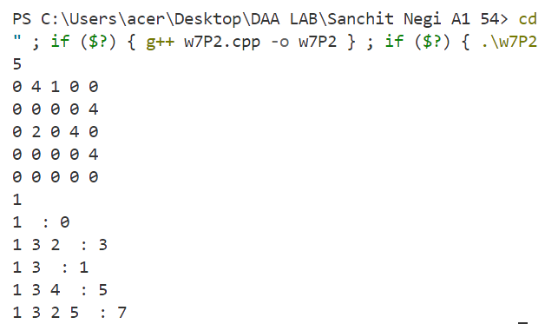

PRACTICAL 21

- Given a directed graph with two vertices ( source and destination). Design an algorithm and implement it using a program to find the weight of the shortest path from source to destination with exactly k edges on the path.

Source Code:

#include <bits/stdc++.h>
using namespace std;
#define INF 1000000000

int shortestPathWithKEdges(vector<vector<int>> graph, int src, int des, int k)
{
int V = graph.size();
int sp[V][V][k + 1];

// Loop for number of edges from 0 to k
for (int e = 0; e <= k; e++)
{
for (int i = 0; i < V; i++) // for source
{
for (int j = 0; j < V; j++) // for destination
{
// initialize value
sp[i][j][e] = INF;

// from base cases
if (e == 0 && i == j)
sp[i][j][e] = 0;
if (e == 1 && graph[i][j] != INF)
sp[i][j][e] = graph[i][j];

// go to adjacent only when number of edges is more than 1
if (e > 1)
{
for (int a = 0; a < V; a++)
{
if (graph[i][a] != INF && i != a && j != a && sp[a][j][e - 1] != INF)
sp[i][j][e] = min(sp[i][j][e], graph[i][a] + sp[a][j][e - 1]);
}
}
}
}
}
return sp[src][des][k];
}

int main()
{
int V;
cin >> V;

vector<vector<int>> graph(V, vector<int>(V));
for (int i = 0; i < V; i++)
{
for (int j = 0; j < V; j++)
{
cin >> graph[i][j];
graph[i][j] = (graph[i][j] == 0 ? 1e9 : graph[i][j]);
}
}

int source, destination, k;
cin >> source >> destination >> k;

int shortestPath = shortestPathWithKEdges(graph, source - 1, destination - 1, k); // 1 based indexing
if (shortestPath == INF)
{
cout << "No path from source to destination with exactly " << k << " edges." << endl;
}
else
{
cout << "Shortest path from (" << source << " to " << destination << ") with exactly " << k << " edges: " << shortestPath << endl;
}

return 0;
}

OUTPUT:

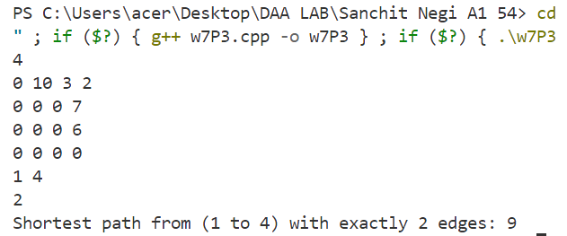

PRACTICAL 22

- Assume that a project of road construction to connect some cities is given to your friend. Map of these cities and roads which will connect them (after construction) is provided to him in the form of a graph. Certain amount of rupees is associated with construction of each road. Your friend has to calculate the minimum budget required for this project. The budget should be designed in such a way that the cost of connecting the cities should be minimum and number of roads required to connect all the cities should be minimum (if there are N cities then only N-1 roads need to be constructed). He asks you for help. Now, you have to help your friend by designing an algorithm which will find minimum cost required to connect these cities. (use Prim's algorithm).

Source Code:

#include <bits/stdc++.h>
using namespace std;

int spanningTree(int V, vector<vector<int>> &adj)
{
priority_queue<pair<int, int>, vector<pair<int, int>>, greater<pair<int, int>>> pq;

// Vector to keep track of the minimum weights
vector<int> key(V, INT_MAX);

vector<bool> inMST(V, false);

// Starting from node 0
pq.push({0, 0});
key[0] = 0;

int sum = 0;

while (!pq.empty())
{
int u = pq.top().second;
pq.pop();

if (inMST[u])
continue;

inMST[u] = true;
sum += key[u];

for (int v = 0; v < V; ++v)
{
if (adj[u][v] && !inMST[v] && adj[u][v] < key[v])
{
key[v] = adj[u][v];
pq.push({key[v], v});
}
}
}

return sum;
}

int main()
{
int n;
cin >> n;
vector<vector<int>> adj(n, vector<int>(n));

for (int i = 0; i < n; ++i)
for (int j = 0; j < n; ++j)
cin >> adj[i][j];

int ans = spanningTree(n, adj);
cout << "Sum of weights of edges of the Minimum Spanning Tree: " << ans << endl;
return 0;
}

OUTPUT:

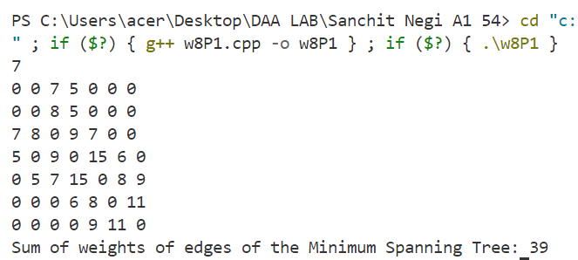q

PRACTICAL 23

- Implement the previous problem using Kruskal's algorithm

Source Code:

#include <bits/stdc++.h>
using namespace std;

// Union-Find Data Structure with path compression
vector<int> parent;

// Find function with path compression
int find(int i)
{
if (parent[i] != i)
parent[i] = find(parent[i]);
return parent[i];
}

// Union function without rank
void Union(int x, int y)
{
int x_parent = find(x);
int y_parent = find(y);
if (x_parent != y_parent)
{
parent[x_parent] = y_parent;
}
}

// Kruskal's algorithm to find the MST
int kruskal(vector<vector<int>> &edges, int V)
{
int sum = 0;
parent.resize(V);

// Initialize the parent array
for (int i = 0; i < V; i++)
{
parent[i] = i;
}

// Sort edges by their weight
sort(edges.begin(), edges.end(), [](const vector<int> &a, const vector<int> &b)
{ return a[2] < b[2]; });

// Process edges
for (const auto &edge : edges)
{
int u = edge[0];
int v = edge[1];
int weight = edge[2];

// If u and v are in different sets, include this edge in the MST
if (find(u) != find(v))
{
Union(u, v);
sum += weight;
}
}

return sum;
}
int main()
{
int V;
cin >> V;

vector<vector<int>> edges;
vector<vector<int>> matrix(V, vector<int>(V));

// Input the adjacency matrix
for (int i = 0; i < V; i++)
{
for (int j = 0; j < V; j++)
{
cin >> matrix[i][j];
if (matrix[i][j] != 0)
{
edges.push_back({i, j, matrix[i][j]});
}
}
}

// Calculate the sum of weights of edges in the MST
int ans = kruskal(edges, V);
cout << "Sum of weights of edges of the Minimum Spanning Tree: " << ans << endl;

return 0;
}

OUTPUT:



PRACTICAL 24

- Assume that same road construction project is given to another person. The amount he will earn from this project is directly proportional to the budget of the project. This person is greedy, so he decided to maximize the budget by constructing those roads who have highest construction cost. Design an algorithm and implement it using a program to find the maximum budget required for the project.

Source Code:

#include <bits/stdc++.h>
using namespace std;

// Union-Find Data Structure with path compression
vector<int> parent;

// Find function with path compression
int find(int i)
{
if (parent[i] != i)
parent[i] = find(parent[i]);
return parent[i];
}

// Union function without rank
void Union(int x, int y)
{
int x_parent = find(x);
int y_parent = find(y);
if (x_parent != y_parent)
{
parent[x_parent] = y_parent;
}
}

// Kruskal's algorithm to find the MST
int kruskal(vector<vector<int>> &edges, int V)
{
int sum = 0;
parent.resize(V);

// Initialize the parent array
for (int i = 0; i < V; i++)
{
parent[i] = i;
}

// Sort edges by their weight
sort(edges.begin(), edges.end(), [](const vector<int> &a, const vector<int> &b)
{ return a[2] > b[2]; });

// Process edges
for (const auto &edge : edges)
{
int u = edge[0];
int v = edge[1];
int weight = edge[2];

// If u and v are in different sets, include this edge in the MST
if (find(u) != find(v))
{
Union(u, v);
sum += weight;
}
}

return sum;
}
int main()
{
int V;
cin >> V;

vector<vector<int>> edges;
vector<vector<int>> matrix(V, vector<int>(V));

// Input the adjacency matrix
for (int i = 0; i < V; i++)
{
for (int j = 0; j < V; j++)
{
cin >> matrix[i][j];
if (matrix[i][j] != 0)
{
edges.push_back({i, j, matrix[i][j]});
}
}
}

// Calculate the sum of weights of edges in the MST
int ans = kruskal(edges, V);
cout << "Sum of weights of edges of the Minimum Spanning Tree: " << ans << endl;

return 0;
}

OUTPUT:

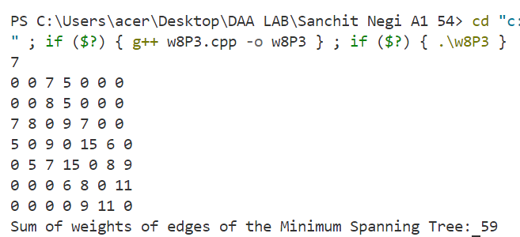

PRACTICAL 25

- Given a graph, Design an algorithm and implement it using a program to implement Floyd Warshall all pair shortest path algorithm.

Source Code:

#include <bits/stdc++.h>
#define INF INT_MAX
using namespace std;
void shortest(vector<vector<int>> &mat)
{
int n = mat.size();
for (int via = 0; via < n; via++)
{
for (int i = 0; i < n; i++)
{
for (int j = 0; j < n; j++)
{
if (mat[i][via] != INF && mat[via][j] != INF)
{
mat[i][j] = min(mat[i][j], mat[i][via] + mat[via][j]);
}
}
}
}
}

int main()
{
int n;
cin >> n;
vector<vector<int>> matrix(n, vector<int>(n));
for (int i = 0; i < n; i++)
{
for (int j = 0; j < n; j++)
{
string val;
cin >> val;
if (val == "INF")
{
matrix[i][j] = INF;
}
else
{
matrix[i][j] = stoi(val);
}
}
}

shortest(matrix);
cout << "Shortest Distance Matrix is" << endl;
for (int i = 0; i < n; i++)
{
for (int j = 0; j < n; j++)
{
if (matrix[i][j] == INF)
{
cout << "INF ";
}
else
{
cout << matrix[i][j] << " ";
}
}
cout << endl;
}
return 0;
}

OUTPUT:

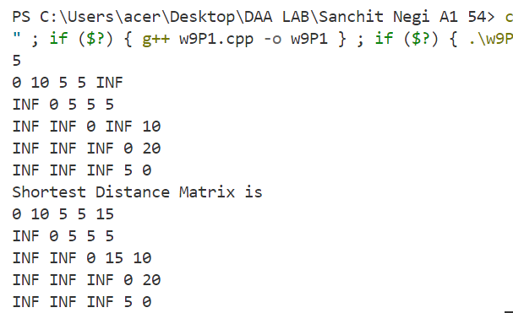

PRACTICAL 26

- Given a knapsack of maximum capacity w. N items are provided, each having its own value and weight. You have to Design an algorithm and implement it using a program to find the list of the selected items such that the final selected content has weight w and has maximum value. You can take fractions of items,i.e. the items can be broken into smaller pieces so that you have to carry only a fraction xi of item i, where 0 ≤xi≤ 1.

Source Code:

#include<bits/stdc++.h>
using namespace std;

bool custom(pair<int,int>a,pair<int,int>b)
{
double r1=(1.0*a.first)/a.second;
double r2=(1.0*b.first)/b.second;

return r1>r2;
}

int main()
{
int n;cin>>n;
vector<int>item(n),weight(n);
for(auto &it:weight) cin>>it;
for(auto &it:item) cin>>it;
int cap;cin>>cap;

vector<pair<int,int>> v(n);
map<pair<int,int>,int>mp;
for(int i=0;i<n;i++)
{
v[i]={item[i],weight[i]};
mp[{item[i],weight[i]}]=i+1;
}

sort(v.begin(),v.end(),custom);

double profit=0.0;
vector<pair<int,double>>ans;
for(auto it:v)
{
if(it.second<cap)
{
profit+=it.first;
cap-=it.second;
ans.push_back({mp[{it.first,it.second}],it.second});
}
else
{
profit+=it.first*((1.0*cap)/it.second);
ans.push_back({mp[{it.first,it.second}],cap});
break;
}
}

cout<<"Maximum value: "<<profit<<endl;
cout<<"item-weight"<<endl;
for(auto it:ans)
cout<<"Item " <<it.first<<" - "<<it.second<<endl;

return 0;
}

OUTPUT:
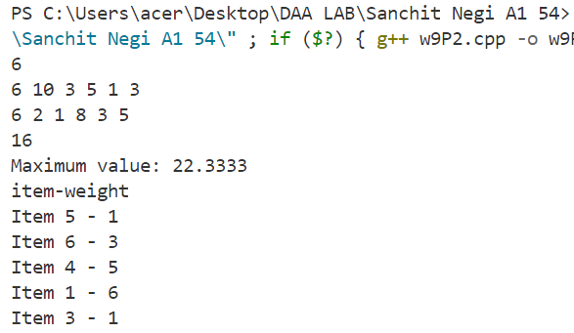

PRACTICAL 27

- Given an array of elements. Assume arr[i] represents the size of file i. Write an algorithm and a program to merge all these files into single file with minimum computation. For given two files A and B with sizes m and n, computation cost of merging them is O(m+n). (Hint: use greedy approach)

Source Code:

#include <bits/stdc++.h>
using namespace std;

bool custom(pair<int, int> a, pair<int, int> b)
{
double r1 = 1.0 * a.first / a.second;
double r2 = 1.0 * b.first / b.second;
return r1 > r2;
}

int main()
{
int n;
cin >> n;
vector<int> v(n);
for (auto &it : v)
cin >> it;

priority_queue<int, vector<int>, greater<int>> pq(v.begin(), v.end());

long long ans = 0;
while (pq.size() != 1)
{
int a = pq.top();
pq.pop();
int b = pq.top();
pq.pop();

ans += a + b;
pq.push(a + b);
}

cout << ans << endl;

return 0;
}

OUTPUT:

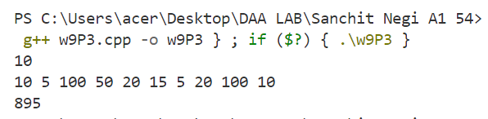

PRACTICAL 28

- Given a list of activities with their starting time and finishing time. Your goal is to select maximum number of activities that can be performed by a single person such that selected activities must be non-conflicting. Any activity is said to be non-conflicting if starting time of an activity is greater than or equal to the finishing time of the other activity. Assume that a person can only work on a single activity at a time.
Source Code:

#include <bits/stdc++.h>

using namespace std;

int main()
{
int n;
cin >> n;

vector<int> start(n), end(n);
for (auto &s : start)
cin >> s;

for (auto &e : end)
cin >> e;

vector<pair<pair<int, int>, int>> activities(n);
for (int i = 0; i < n; ++i)
activities[i] = {{end[i], start[i]}, i + 1};

sort(activities.begin(), activities.end());

vector<int> selectedIndices;
int count = 0;
int lastEndTime = 0;

for (auto &activity : activities)
{
if (activity.first.second >= lastEndTime)
{
lastEndTime = activity.first.first;
selectedIndices.push_back(activity.second);
count++;
}
}

cout <<"No. of non-conflicting activities: "<< count << endl;
cout <<"List of selected activities: " << endl;
sort(selectedIndices.begin(),selectedIndices.end());
for (auto index : selectedIndices)
{
cout << index << " ";
}
cout << endl;

return 0;
}

OUTPUT:

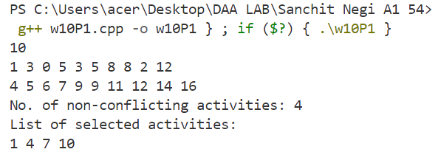

PRACTICAL 29

- Given a long list of tasks. Each task takes specific time to accomplish it and each task has a deadline associated with it. You have to design an algorithm and implement it using a program to find maximum number of tasks that can be completed without crossing their deadlines and also find list of selected tasks.

Source Code:

#include <bits/stdc++.h>

using namespace std;

int main()
{
int n;
cin >> n;

vector<int> times(n), deadlines(n);
for (int i = 0; i < n; ++i)
cin >> times[i];

for (int i = 0; i < n; ++i)
cin >> deadlines[i];

vector<pair<pair<int, int>, int>> tasks(n);
for (int i = 0; i < n; ++i)
{
tasks[i] = {{deadlines[i], times[i]}, i + 1};
}

sort(tasks.begin(), tasks.end());

priority_queue<pair<int, int>> maxHeap;
int totalTime = 0;
vector<int> selectedIndices;

for (auto &task : tasks)
{
int duration = task.first.second;
int deadline = task.first.first;
int index = task.second;

// If the current task can be completed within its deadline, add it to the heap
if (totalTime + duration <= deadline)
{
maxHeap.push({duration, index});
totalTime += duration;
selectedIndices.push_back(index);
}

// If the current task cannot be completed within its deadline, consider replacing a longer task
else if (!maxHeap.empty() && maxHeap.top().first > duration)
{
// Remove the longest duration task from the total time and the heap
totalTime -= maxHeap.top().first;
auto it = find(selectedIndices.begin(), selectedIndices.end(), maxHeap.top().second);
if (it != selectedIndices.end())
{
selectedIndices.erase(it);
}

maxHeap.pop();
// Add the current task's duration to the heap and total time
maxHeap.push({duration, index});
totalTime += duration;
selectedIndices.push_back(index);
}
}

cout << "Maximum number of tasks that can be completed: " << maxHeap.size() << endl;
sort(selectedIndices.begin(), selectedIndices.end());
cout << "Selected task number: "<< endl;
for (int index : selectedIndices)
cout << index << " ";
cout << endl;

return 0;
}

OUTPUT:

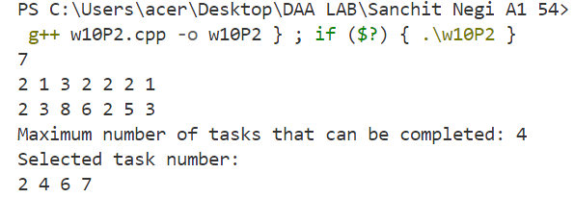

PRACTICAL 30

- Given an unsorted array of elements, design an algorithm and implement it using a program to find whether majority element exists or not. Also find median of the array. A majority element is an element that appears more than n/2 times, where n is the size of array.

Source Code:

#include <bits/stdc++.h>
using namespace std;

int main()
{
int n; cin >> n;
vector<int> v(n);
for (int i = 0; i < n; ++i)
cin >> v[i];

map<int, int> mp;
string ans = "NO";
for (auto it : v)
{
mp[it]++;
if (mp[it] > n / 2)
ans = "YES";
}
cout << ans << endl;
sort(v.begin(), v.end());
if (n % 2 != 0)
cout << "Median: " << v[n / 2] << endl;
else
cout << "Median: " << 1.0 * (v[(n - 1) / 2] + v[n / 2]) / 2.0 << endl;

return 0;
}

OUTPUT:

